Prototype chain and prototype inheritance in javascript

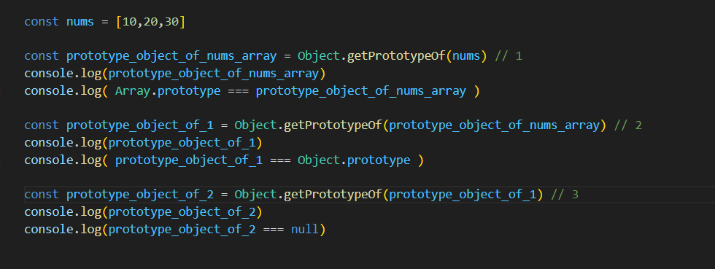

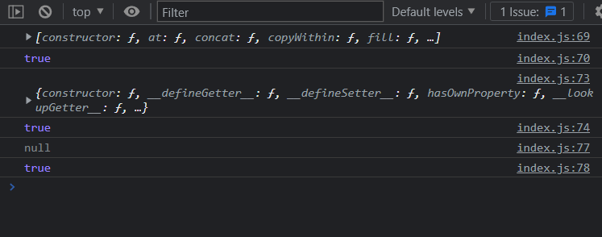

See this code and understand the prototype chain in javascript

**In java script every object has a prototype object, thus a prototype chain is formed**

**The prototype object acts as a template or blueprint for creating new object**

**In java script an object can have only one prototype object at a time**

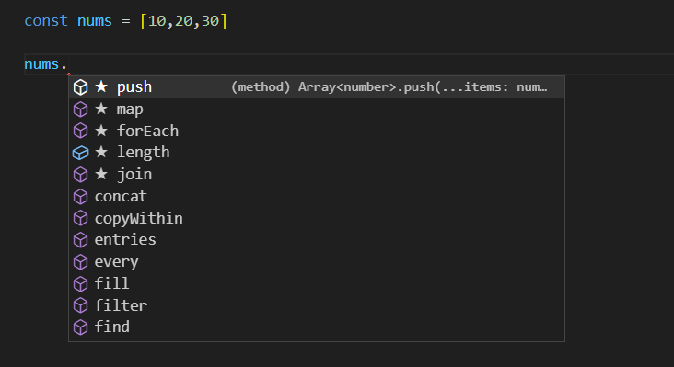

Where does the array nums has all these methods

It’s because the array nums had inherited these methods from the prototype object known as “Array.prototype”

And the prototype object of object “Array.prototype” object is “Object.prototype”

And the prototype object of object “Object.prototype” is null

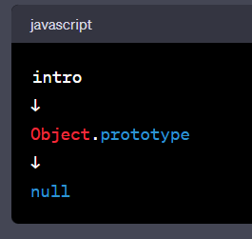

A prototype chain visual representation

